Auto Purge

The auto purge function uses configuration values to determine the frequency and amount of order data to purge from the Inventory System order tables. Auto Purge will eliminate the error that can occur when Renban numbers wrap around.

Access Auto Purge functionality configuration through the main configuration screen accessed from the File|Configuration menu selection.

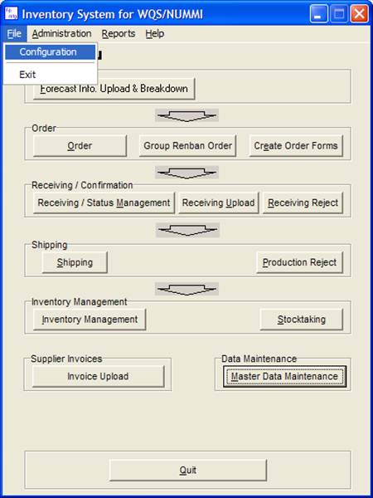

Click the Auto Pure tab to access the purge settings

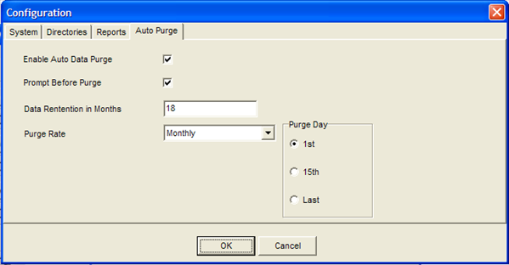

- Enable Auto Data Purge – If checked, the program at start up will run Auto Purge execution if required.
- Prompt Before Auto Purge – If checked, the program will display confirmation dialog before executing the Auto Purge. If the user declines to execute Auto Purge the function will attempt execution on the next program run.
- Data Retention in Months – Number of months of order data to keep.
- Purge Rate – How often to run the Auto Purge function.

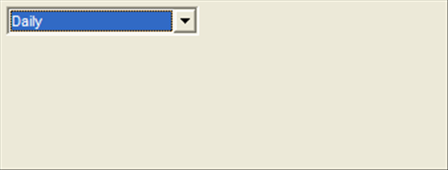
- Daily – Auto Purge will check for purge data once a day.

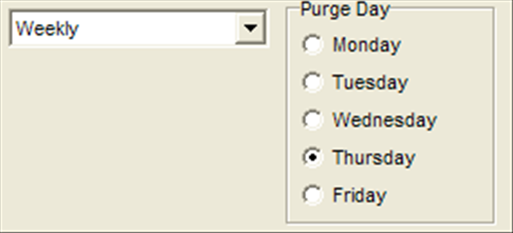
- Weekly – Auto Purge will run once a week on the specified day.

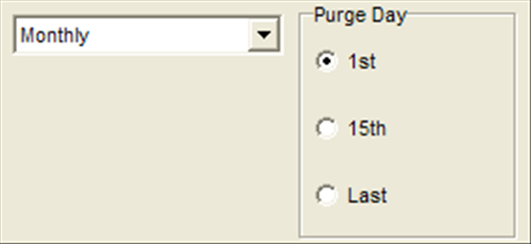
- Monthly – Auto Purge will run once a month on the specified day.

